Game Information

Date |  | League
Home Team |  | Visiting Team

Officials Information

Referee 1 |  | Referee 2
Linesman 1 |  | Linesman 2

Penalty Summary

Player Name | License Number | No. | Team  H/V | Period | Time | Penalty | Tariff | Rule No. | On Game Sheet  Y/N | Injury  Y/N
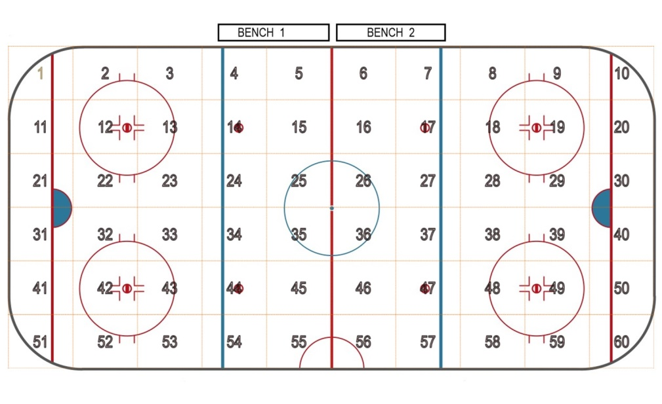
Referees Report:
Team on Bench 1:
Team on Bench 2:

Set the scene:

Where on the ice were you?

Where did the incident take place?

What happened?

What penalty was called?

State the rule you applied and why?

Did anything happen after the officials intervened?

Name of Official submitting the form:
Date of the form being submitted:

